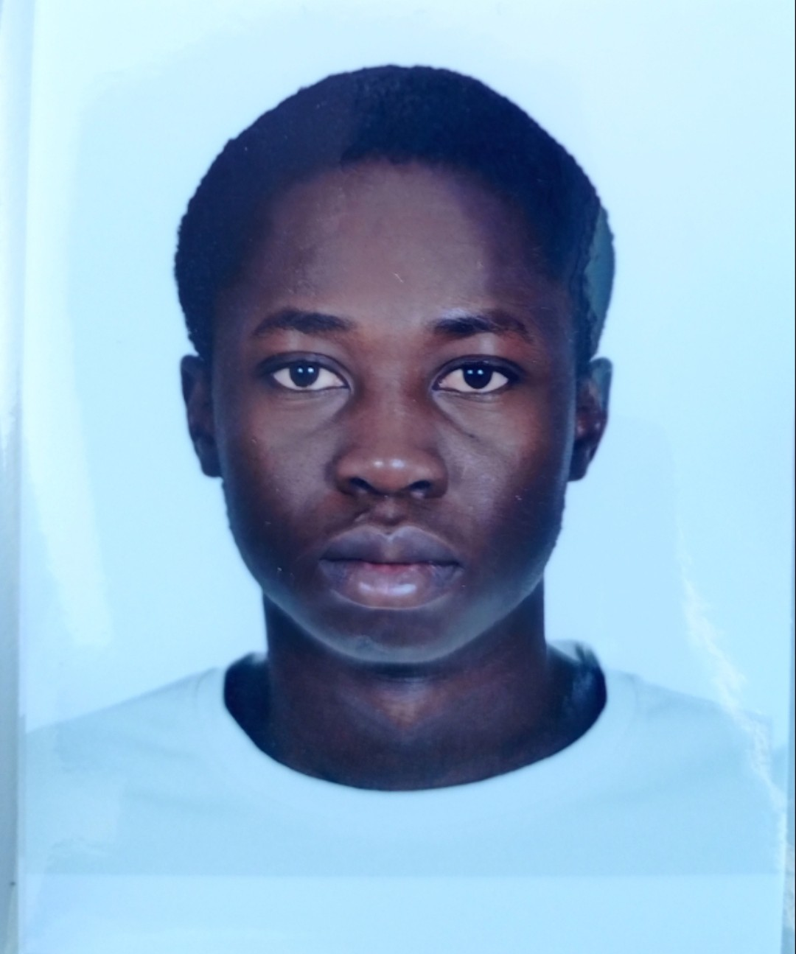
MOUSSA TRAORE
Antalya, Türkiye | moussatraore8490@gmail.com | +90 544 545 62 43 | https://www.linkedin.com/in/moussa-traor%C3%A9-3023972a8 | https://github.com/MOUSSA-TRAORE1

SUMMARY
Final-year Computer Engineering student with a 3.90/4.00 GPA and full scholarship, interested in software engineering and AI, and currently looking for an internship opportunity.

EDUCATION

Antalya Bilim University
B.Sc. Computer Engineering, GPA: 3.90 / 4.00 | Full Scholarship
Relevant Coursework: Data Structures, Algorithms, Object-Oriented Programming, Software Engineering, Database Systems, Operating Systems, Computer Architecture, Web Programming

EXPERIENCE

AI Project Contributor – NOOVOY AI (Ongoing)
- Contributing to the development of an AI-powered HR onboarding solution.
- Working with LLM and retrieval-based concepts, including RAG and data-processing workflows.
- Participating in technical research, architecture discussions, and prototype development.

Software Development Intern – Evrensel Bilişim Jul,2026 – Aug,2026
- Assisting in software development tasks within a professional environment
- Applied programming, debugging, and problem-solving skills to practical development tasks
- Used Git/GitHub and gained experience with professional development workflows and team collaboration.

Independent Software & AI Developer (Ongoing)
- Designed and developed multiple personal projects in software engineering and AI
- Built an AI Study Assistant using embeddings and Retrieval-Augmented Generation (RAG) concepts
- Developed applications using Java (GUI), Python, and web technologies
- Maintained and updated projects on GitHub with continuous improvements
- Actively learning backend development and modern AI technologies

PROJECTS

AI Study Assistant (Ongoing)
- Developing an AI-powered assistant for learning support.
- Implementing text embedding and semantic retrieval techniques
- Exploring RAG-based architecture for intelligent responses
- Project progress and updates available on GitHub

OpporTrack — Personalized Opportunity Discovery Platform

(Product & System Design | Early Stage)
- Designing a centralized platform for discovering scholarships, internships, jobs, competitions, programs, and conferences.
- Defining a personalized discovery approach based on users' profiles, interests, and preferences.
- Currently working on requirements analysis, core feature definition, and system architecture.

Embedded Systems Projects
- Developed microcontroller-based applications involving LCD displays, keypads, timers, interrupts, and ADC interfaces.
- Applied hardware-software integration concepts through laboratory and personal projects.

Database Projects
- Implemented SQL queries involving joins, aggregation, grouping, subqueries, views, and stored procedures.
- Applied relational database concepts through coursework and practical exercises.

TECHNICAL SKILLS

Programming Languages: Java, Python, C, C++, SQL, JavaScript(basics)
Web & Software Development: HTML/CSSObject-Oriented Programming, GUI Development (Java Swing), Debugging, Version Control (Git/GitHub), REST API Concepts
Artificial Intelligence: AI Fundamentals, Prompt Engineering, Large Language Models (LLMs), Retrieval-Augmented Generation (RAG) Concepts
Databases: SQL Server, MySQL, Joins, Subqueries, Views, Stored Procedures, Database Design Fundamental Embedded Systems: 8051 Microcontroller, LCD Interfacing, Keypad Interfacing, ADC Applications, Timers and Interrupts
Tools: VS Code, IntelliJ IDEA, MATLAB, Linux (Basic)
Soft Skills: Problem Solving, Teamwork, Communication, Adaptability

LEADERSHIP & INVOLVEMENT

Founder & President - OT TechX
- Founded OT TechX, a technology initiative focused on products and services in technology and computer engineering.
- Leading the initiative's development and direction across technology, product, and service activities.

President – [Antalya Malian Student Association]
- Led and coordinated activities and initiatives within the organization
- Organized events and collaborated with team members
- Developed leadership, communication, and project management skills

Member – Optica (Optics & Photonics Organization)
- Engaged in scientific and technical community activities
- Participated in discussions and learning initiatives related to technology and engineering

Volunteer Experience
- Contributed to community or organizational initiatives
- Worked in team environments and supported event coordination

LANGUAGES
- English — Fluent
- French — Fluent
- Turkish — Intermediate
- Bambara — Fluent

